What is software ?

**How should we define software ?**

Software definition must have following terms:

***(1) Instructions*** *(computer programs) that when executed provide desired function and performance,*

***(2) Data structure*** *that enable the programs to adequately manipulate information, and*

***(3) Documentation*** *that describe the operation and use of the programs.*

**Software Characteristics**

* Software is both a product and a vehicle for developing a product.
* Software is engineered not manufactured.
* Software does not wear out, but it does deteriorate.
* Currently, most software is still custom-built.

**Failure curve for hardware**

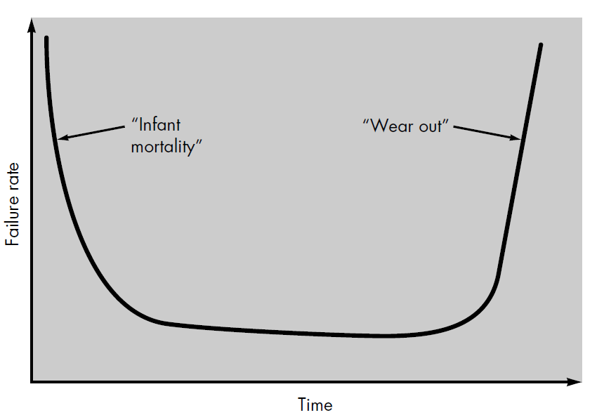

**Idealized and actual failure curves for software**

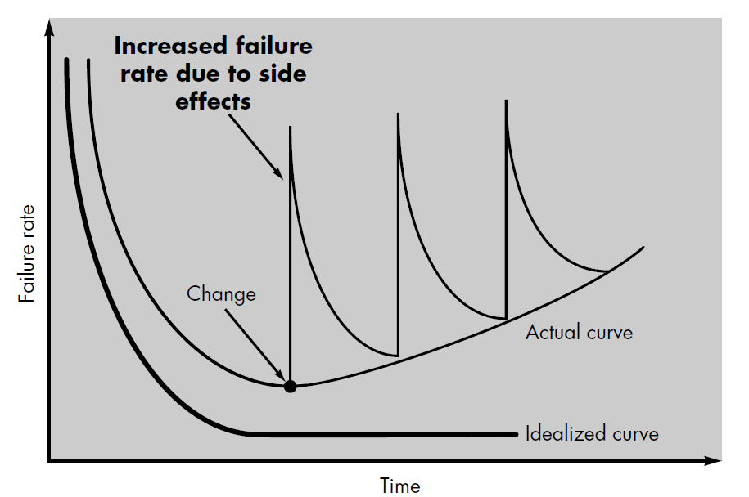

**Software application**

* System Software
* Real time software
* Business software
* Engineering and scientific software
* Embedded software
* Personal computer software
* Web-based software
* Artificial intelligence software**.**